

Sultan Qaboos University
College of Engineering
Petroleum and Chemical Engineering Department
Chemical Reaction Engineering
CHPE4512
Production of Cumene
Memo 4
Section 02
Group 03
Submitted by: | ID | Task
Mohammed Ibrahim Al-Hinai | 138348 | Part 3,4
Omar Sulaiman Al-Ruqaishi | 141761 | Part 1,2
Majid Mohammed Al-Nabhani | 138708 | Part 1,2
Omar Yahya Al-Shaqsi | 141955 | Leader (Part 3,4)
Sufiyan Humaid Al-Fazari | 139364 | Part 3,4
Husam Jaber Al-Rawahi | 139369 | Part 1,2

Table of Contents
Chapter 4: Multiple Reaction System 3
Assumptions 3
4.1 Effect of Weight of Catalyst on the Flow Rate of Spices 3
4.2 Reaction Pathway Diagram for Multiple Reactions of Cumene Production 5
4.3 Selectivity vs. Temperature Analysis: 6
Appendix : 9

Figure 1: Mole Flow of Species Versus the Weight of the Catalyst 4
Figure 2: Reaction Pathway for Cumene Production including Primary and Secondary Reactions 5
Figure 3 :Selectivity vs. Temperature Analysis at a constant reactant conversion 7

Table 1: Specification used for python code 3
Table 2 : Effect of temperature on selectivity, yield, and required catalyst weight . 6

Chapter 4: Multiple Reaction System

Assumptions
- Isothermal Operation: The reactor is assumed to operate at a constant, uniform temperature throughout the bed.
- Reactor Configuration: Based on Memo 3, modeled as a Packed Bed Reactor (PBR) with pressure drop calculated via the Ergun Equation.
- Catalyst Properties:
  - Particle Size: 5 mm (as specified in the memo3).
  - Density: 1150 kg/m³ .
  - Void Fraction: 0.5.
- Kinetic Parameters:
  - Rate Constants: k₁= 2.8×10⁷ m⁶/(kmol·kgcat·s) k₂= 2.32×10⁹ m⁶/(kmol·kgcat·s)
  - Activation Energies: E₁= 104,174$ J/mol E₂ = 146,742 J/mol
  - Reaction Orders: First order with respect to each reactant as per the rate laws
r₁ = k₁C_{A}C_{B} and r₂ = k₂C_{A}C_{C}.

4.1 Effect of Weight of Catalyst on the Flow Rate of Spices
The purpose of this memo is to modify our reactor by introducing multiple reactions instead of a single reaction. One of the reactions comprises two complex reactions, one of which is the formation of cumene. These reactions include.
$$1) C_{6}H_{6}+ C_{3}H_{3} → C_{9}H_{12}$$
$$2) C_{9}H_{12}+ C_{3}H_{3} → C_{12}H_{18}$$
The following relation are obtained from python.
Table 2: Specification used for python code
Parameters | Value
Weight (kg) | 44,610
Volume (m³) | 38.8
D (m) | 2.15
L (m) | 10.75
Nt | 4000
T (K) | 628
P (bar) | 35
F_{A0} (mol/s) | 27.750
F_{B0} (mol/s) | 30.750
F_{I} (mol/s) | 1.460
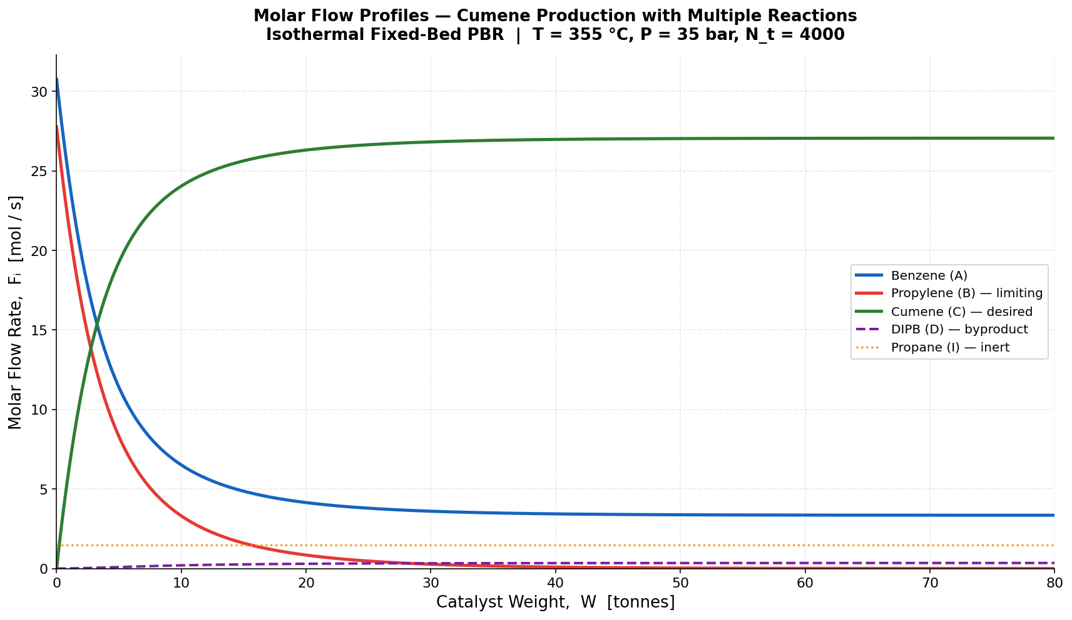
Figure 1: Mole Flow of Species Versus the Weight of the Catalyst
The molar flows of all substances in the reactor as a function of the weight of the catalyst have been presented in the picture above. It can be noticed that, with an increase in the catalyst’s weight, the molar flow of both benzene and propylene is gradually declining. Since propylene reacts in two different processes, namely, to form cumene and the formation of other substances, it gets reduced much faster than benzene.
However, the molar flow rate of cumene is quite high at the beginning stage of the reactor, implying that this is indeed the expected output product. As a result of the reduction in reactant concentration and secondary product formation, the rate of accumulation slows as the amount of catalyst becomes bigger. Side reactions play an increasingly important role in relation to larger amounts of catalyst.
On the contrary, since it does not participate in any chemical reaction, the inert material (propane) remains constant through the entire process inside the reactor. As for the graph, it clearly shows that an increase in catalyst weight enhances the output of cumene, and at the same time, it displays the creation of by-products.

4.2 Reaction Pathway Diagram for Multiple Reactions of Cumene Production

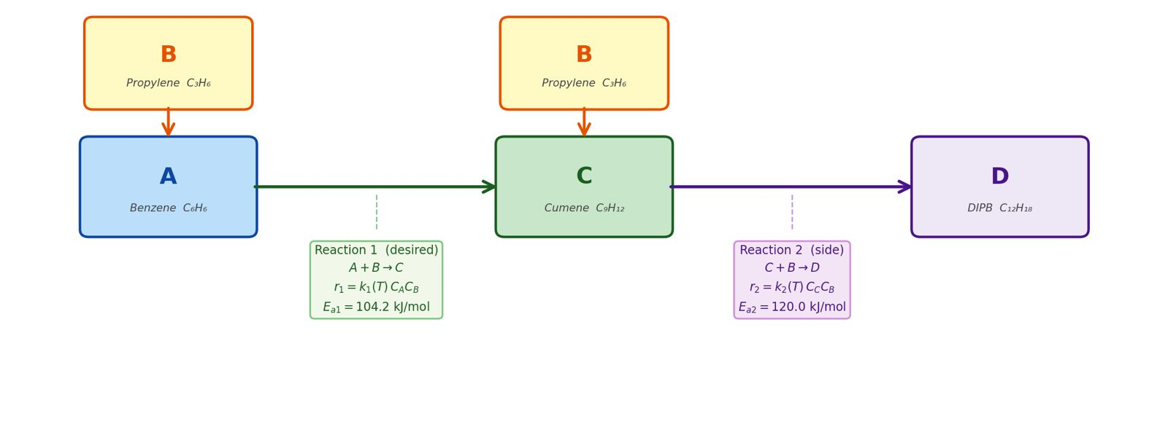
Figure 2: Reaction Pathway for Cumene Production including Primary and Secondary Reactions
The reaction scheme that is used for the formation of Cumene follows a combination of series and parallel routes, whereby the desired end product Cumene can react again to form the unwanted byproduct. The reactions involved are:
- Primary Reaction (Desired Pathway)
The main reaction is the alkylation of Benzene (A) with Propylene (B) to form the desired product, Cumene (C).
- Stoichiometry: A + B > C
- Reaction Rate: r₁ = k₁(T)C_{A}C_{B}
- Activation Energy: E_{a1} = 104.2 kJ/mol
- Secondary Reaction (Side/Byproduct Pathway)
Because Cumene's aromatic ring is very reactive, it competes with Benzene for the available Propylene. Cumene (C) reacts with additional Propylene (B) to form the overalkylated byproduct, Diisopropylbenzene (DIPB) (D).
- Stoichiometry: C + B > D
- Reaction Rate: r₂ = k₂(T)C_{C}C_{B}
- Activation Energy: E_{a2} = 120.2 kJ/mol
Analysis of Pathways:
As illustrated in Figure 2, Propylene (B) is consumed in both the primary and secondary reactions. Because it is the limiting reactant, the competing consumption of Propylene by the newly formed Cumene directly impacts overall yield. Also, the activation energy for the byproduct formation (E_{a2} = 120.2 kJ/mol) is higher than the activation energy for the desired Cumene formation (E_{a1} = 104.2 kJ/mol). This difference indicates that the side reaction is more sensitive to temperature changes than the primary reaction, meaning temperature control within the reactor will be an important factor in maximizing selectivity of the desired product.

4.3 Selectivity vs. Temperature Analysis:
Table 3 : Effect of temperature on selectivity, yield, and required catalyst weight .
Temp (K) | Conv (XA) | Selectivity to B | Selectivity to D | Yield B | Require W (Kg)
600 | 0.99 | 0.9468 | 0.0266 | 0.9373 | 84128.7609
620 | 0.99 | 0.9332 | 0.0334 | 0.9239 | 43109.4432
626 | 0.99 | 0.9288 | 0.0356 | 0.9195 | 35532.9405
650 | 0.99 | 0.9097 | 0.0451 | 0.9006 | 16935.4338
670 | 0.99 | 0.8922 | 0.0539 | 0.8833 | 9474.4084

From the table results the conversion of reactant A was kept constant at 0.99 for all temperatures. This confirms that the comparison is valid and we can see how temperature affects selectivity. The temperatures analyzed were 600 K, 620 K, 626 K 650 K and 670 K. Looking at the selectivity to product B it is highest at 600 K with a value of 0.9468. As temperature increases, selectivity to B decreases. At 670 K selectivity drops to 0.8922. This shows that higher temperatures reduce product B formation. The selectivity to byproduct D shows the trend. At 600 K it is low (0.0266). Increases with temperature and reaches 0.0539 at 670 K. This means higher temperatures promote byproducts. The yield of product B decreases with temperature. At 600 K the yield is 0.9373, which's the highest. As temperature increases the yield drops to 0.8833 at 670 K. Since conversion of reactant A is constant this decrease is mainly due to selectivity to product B. In terms more of reactant A is converted into byproducts instead of product B at higher temperatures. Another important observation, from the table is the required catalyst weight. At 600 K the required weight is large 84,128 kg. As temperature increases the required catalyst weight decreases. At 670 K it is about 9,474 kg. This shows that higher temperatures make the reaction faster. So less catalyst and a smaller reactor size are needed to achieve the conversion of reactant A.

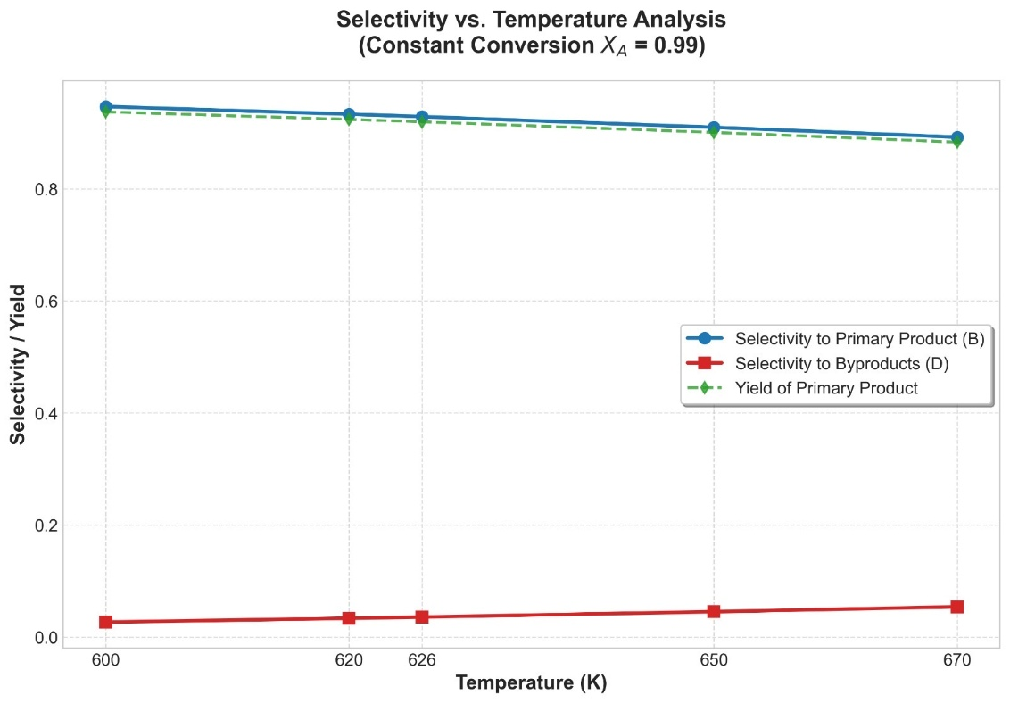
Figure 3 :Selectivity vs. Temperature Analysis at a constant reactant conversion
The graph of selectivity and yield versus temperature shows the patterns we see in the table. The line for selectivity to product B goes down smoothly as temperature goes up. This confirms that the reaction we want happens less at temperatures. The line, for byproduct selectivity goes up with temperature. This shows that unwanted reaction becomes more important at temperatures. The values are smaller compared to the product, but the trend is clear. The yield of product B also goes down with temperature like the selectivity curve. This makes sense because yield depends on selectivity when conversion stays the same. The graph helps us compare all trends at once. It confirms that 600 K gives the results for making the product we want.
Discussion:
Both the table and the graph clearly demonstrate that temperature plays an important role in the product formation process. The lower the temperature, the higher is the amount of the desirable product B obtained; however, higher temperatures lead to an increase in the amount of side products. Optimal temperature to obtain a maximal product B yield is 600 K.
It can be seen that the undesired process is more temperature-dependent. With increasing temperature, the rate of the undesired process becomes greater than the rate of the desirable process, which results in lower selectivity of product B synthesis.
Trade Off Analysis:
Although 600 K provides maximum selectivity and conversion, it does not necessarily follow that this temperature is optimal under all circumstances. There is always a trade-off between selectivity and reactor volume.
Low temperature (600 K): The kinetics of the reaction at such temperature is low. Consequently, a large quantity of the catalyst will be needed for the given conversion. Hence, the reactor will be large, which would lead to increased costs.
High temperature (670 K): Conversely, due to rapid kinetics, a smaller reactor can be used with low conversion, but the formation of more byproducts is inevitable since selectivity is low in this case. Thus, there is always a compromise between these two aspects:
Low temperature causes high selectivity and large reactors.
High temperature cause small reactor and low selectivity.
In practice, the optimum is chosen depending on the economic feasibility and product quality.

Appendix :
